SPORTY SHOES

(AN E-COMMERCE WEBSITE)

GITHUB LINK: https://github.com/AnishAugustin09/Sporty-Shoes

**This document contains the:**

* Sprint Planning
* Flow of Project
* Concepts used in Project
* Working on Eclipse IDE
* Conclusion

**Sprint Planning:**

For this project, I’ve planned to complete the project in 4 Sprints. And the task is completed according to that. And This is a Backend Project so no Frontend Technologies user here

**Flow of Project:**

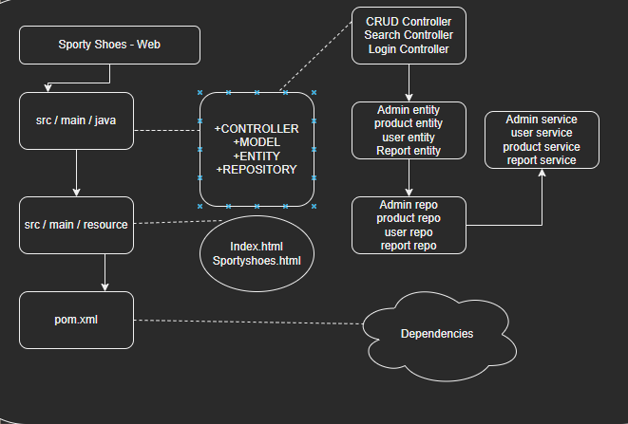

**Project Flow:**

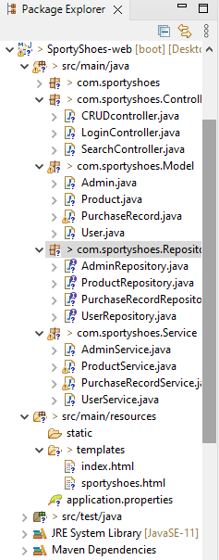

**Concepts used in Project:**

* HTML
* JAVA , API, MAVEN
* H2 DATABASE
* SPRING TOOL SUITE 4
* Tomcat Server 9.0
* Git & Github
* POSTMAN

**Project Flow:**

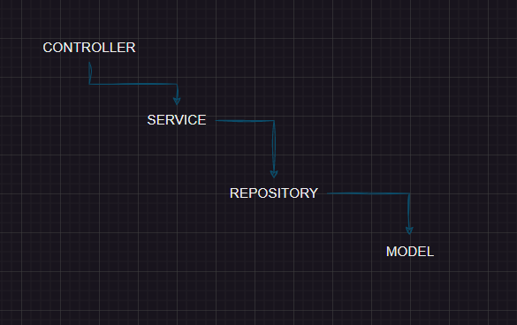

**Working on SPRING TOOL SUITE 4 IDE:**

Step 1: Creating a new Spring Starter Project in STS

● Open STS

● Go to File -> New -> Spring Starter Project --> Next.

● Enter GroupID & ArtifactID click 🡪Next

● Select your project require dependencies

● click FINISH.

**Step 2:** Writing a program in JAVA for the entry point of the application (**LOGINCONTROLLER).** This code will redirect to another pager

**Step 3:** It’ll take you to the **INDEX.HTML** page, where the admin can login with credentials.

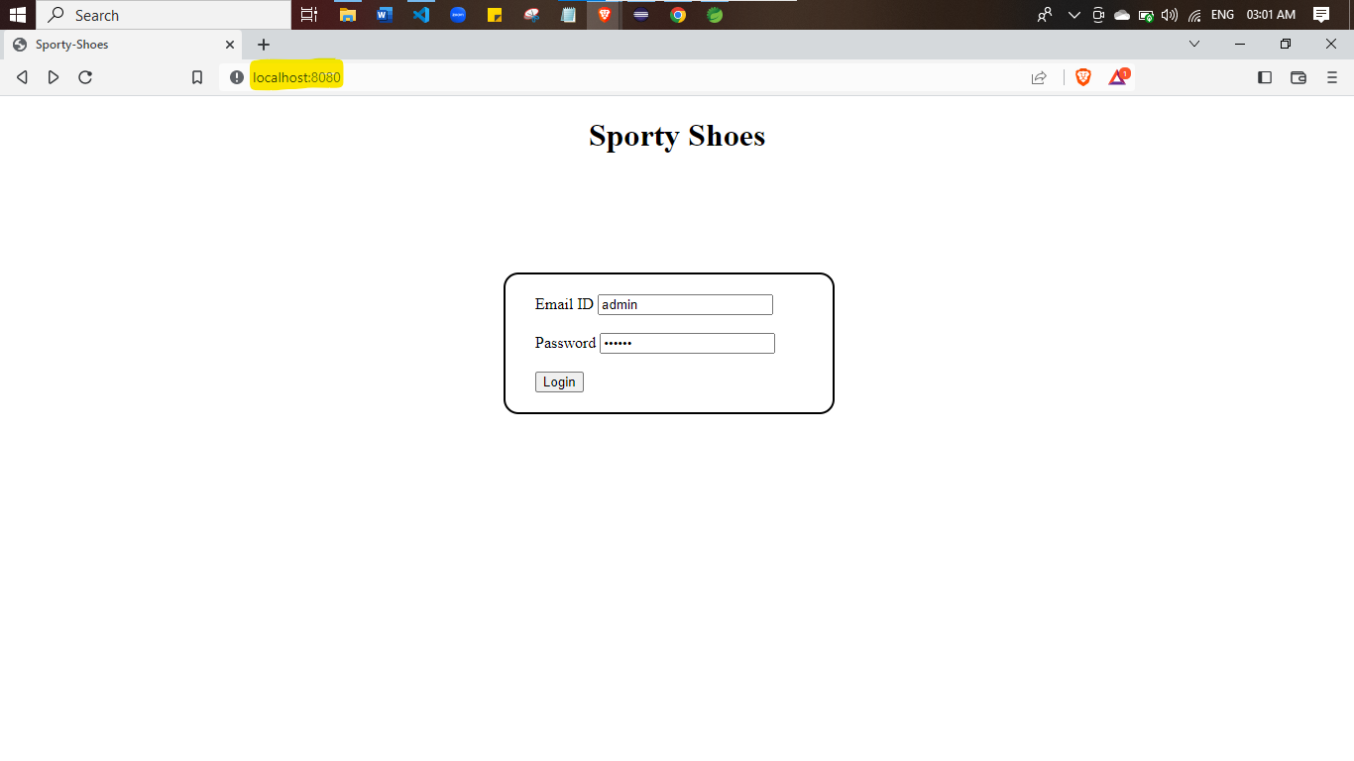

**Step 4:** By giving the email id as **admin** & password as **121212,** you can enter into the main page. The main page will have some options to view some methods in browser itself.

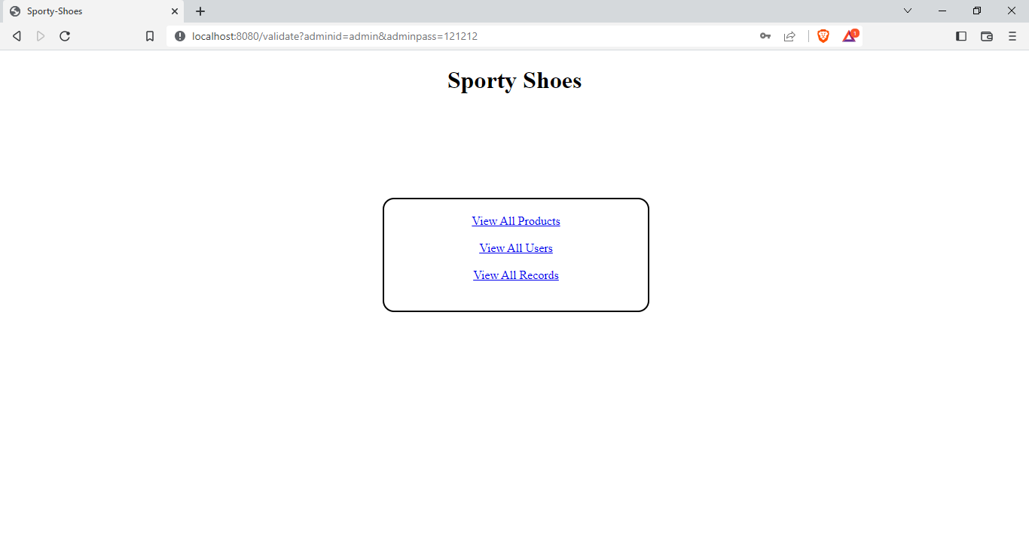

**Step 5:**  Here the admin can access some methods like view report, view users & view product. **However this project is fully based on the Backend API calls so I didn’t much focused on frontend.**

**Step 6:** Once the Admin email id and password has validated, the admin can focus on

* View Products
* View Users
* View Reports
* Add Product
* Update Product
* Delete Product
* Add user
* Update User
* Delete User
* Add Report
* Update Repost
* Delete report
* View Report by Date
* View Report by Category
* View User by Email &
* The Admin can update password if he/she wants

**Step 7:** Once the program started running, You can test the H2- CONSOLE embedded with Spring

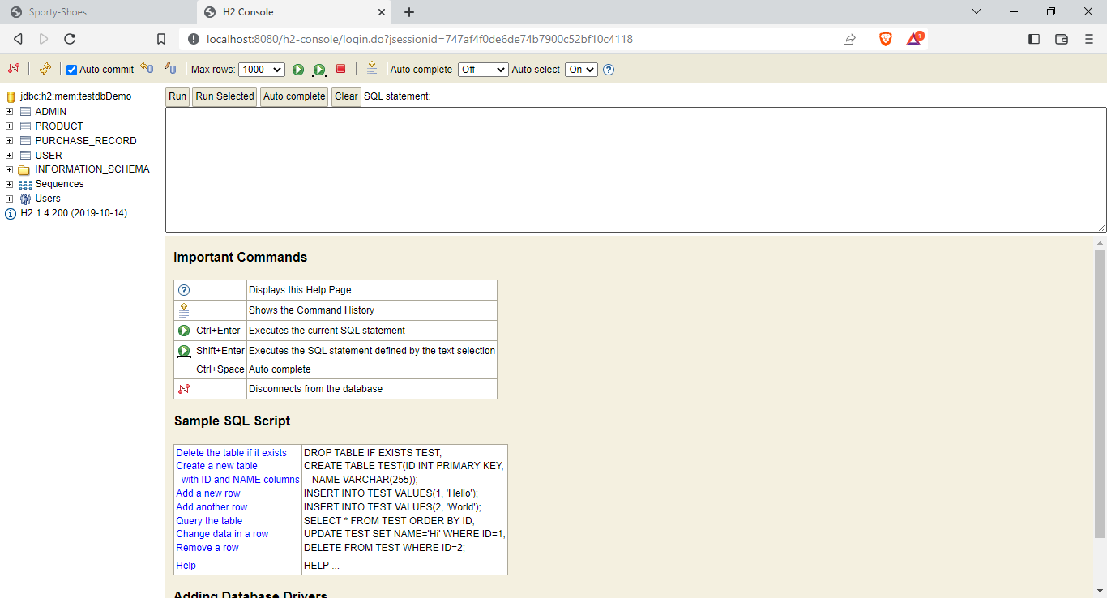

**View Products :**

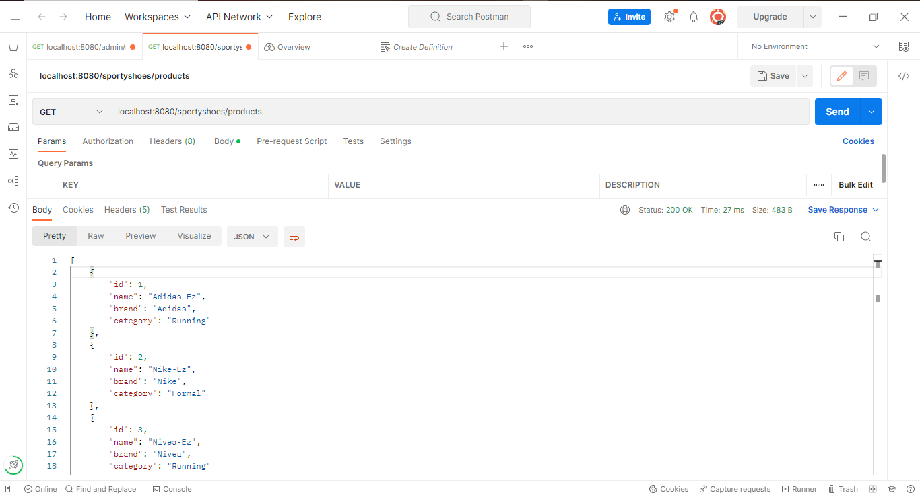

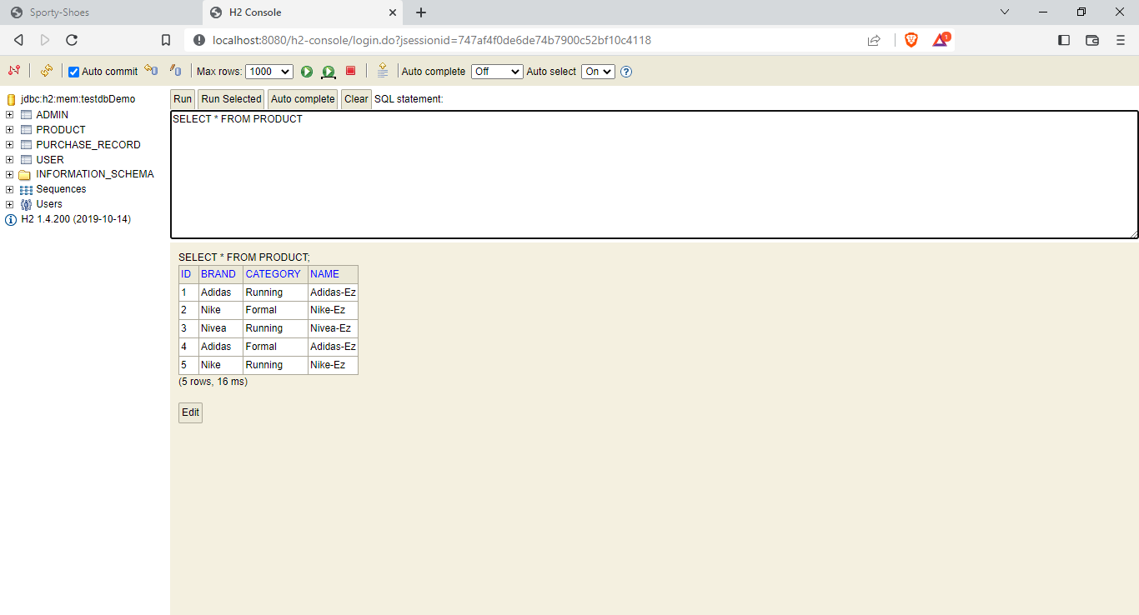

**View Users :**

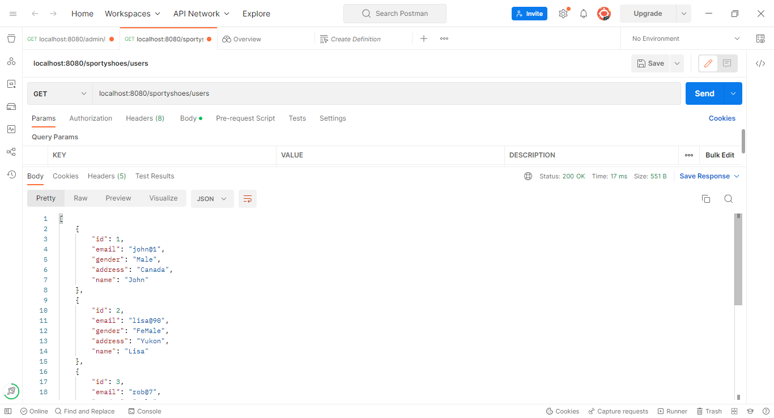

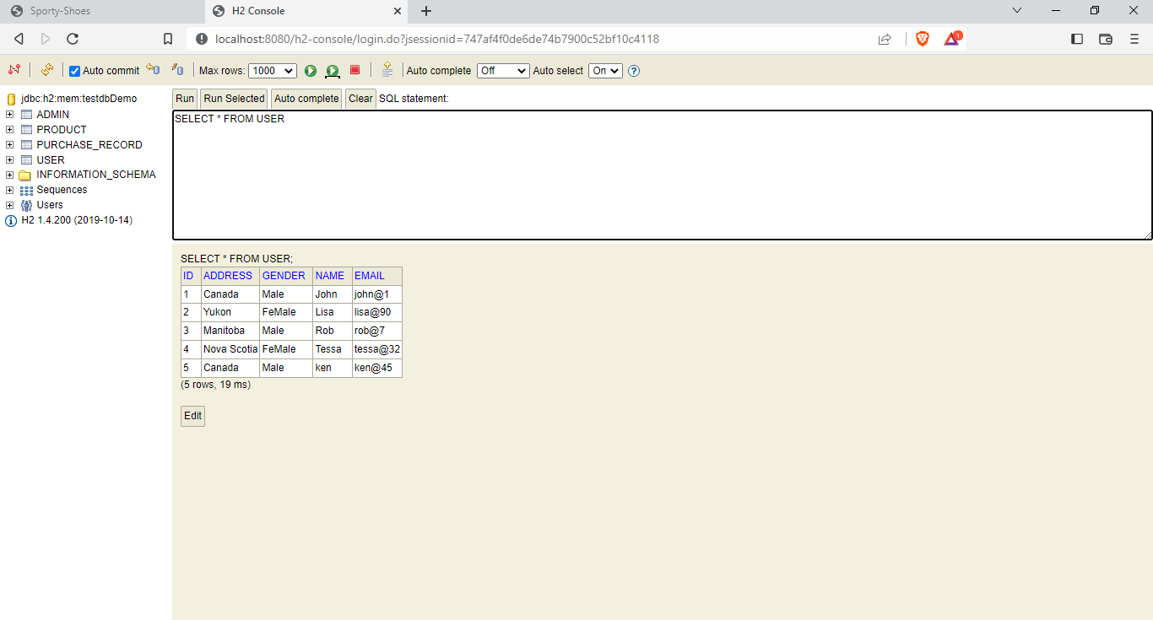

**View Reports :**

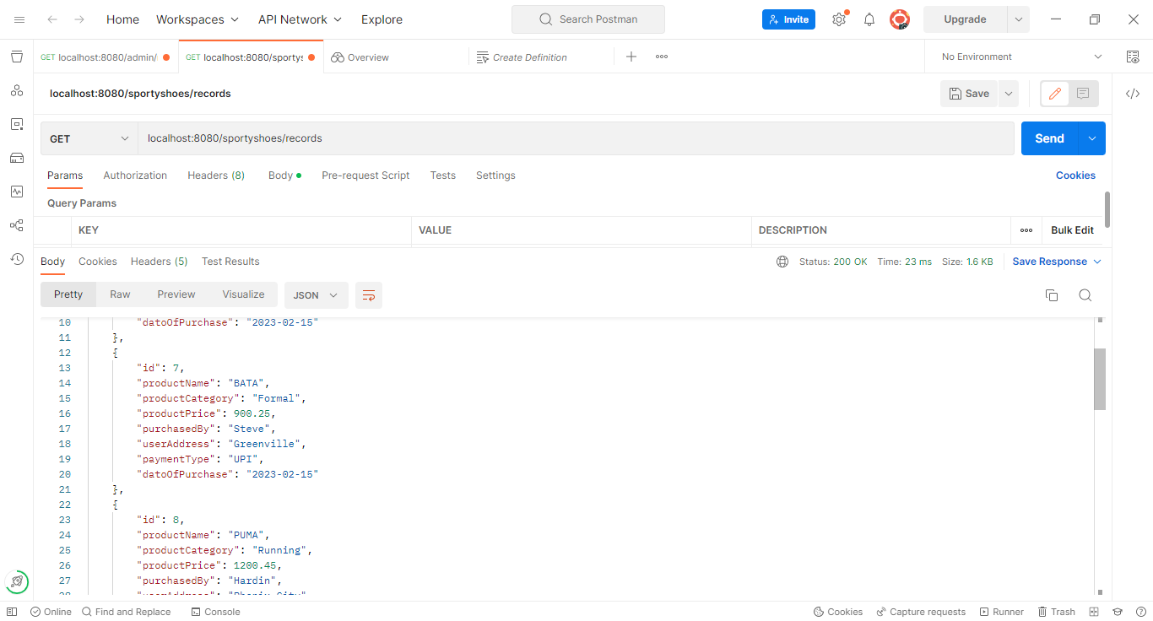

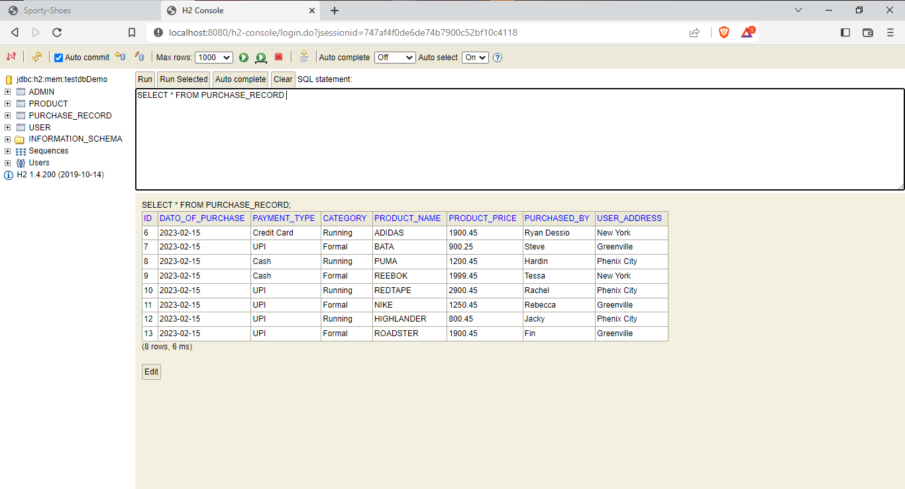

**Add Product :**

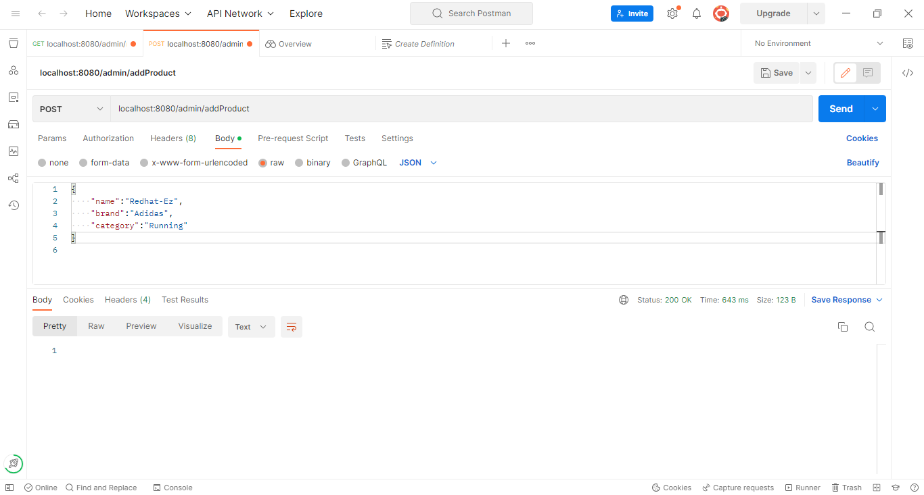

**Update Product :**

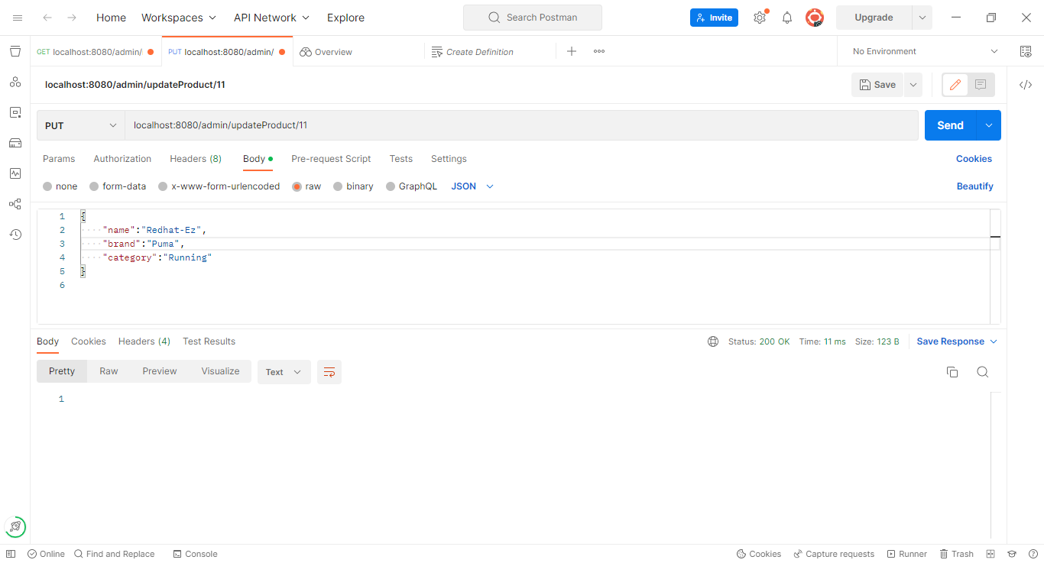

**Delete Product :**

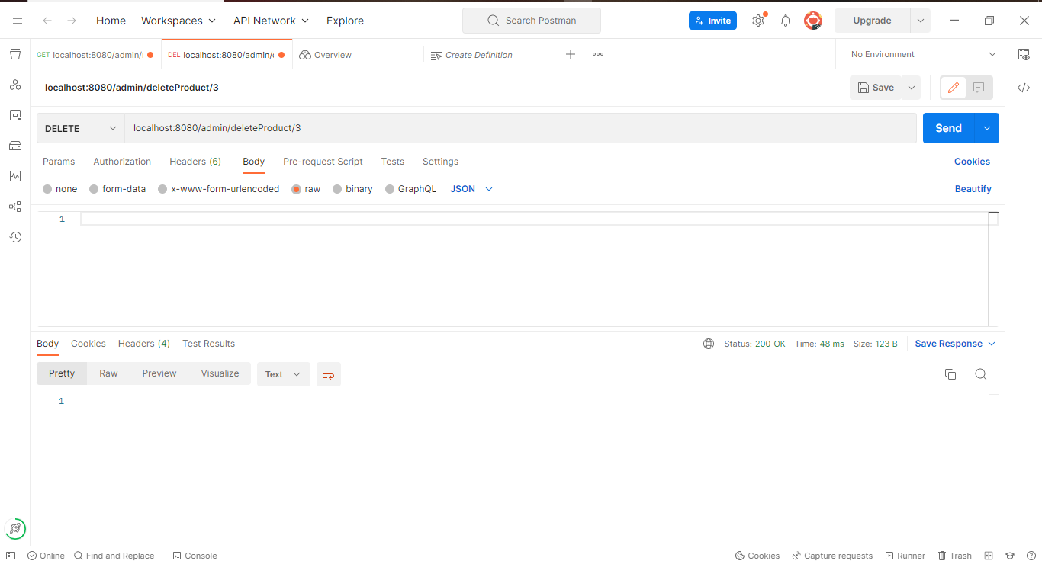

**Main Conditions from the Document**

* **search users**
* **purchase reports filtered by date and category**
* **There will be an admin to manage the website. An administrator login will be required to access the admin page.**

This conditions has done in project using the **NATIVEQUERY** concept.

**SEARCH USERS :**

By using Native Query, the search user option can enable. This Search user will search by the email of the use which we’re Searching.

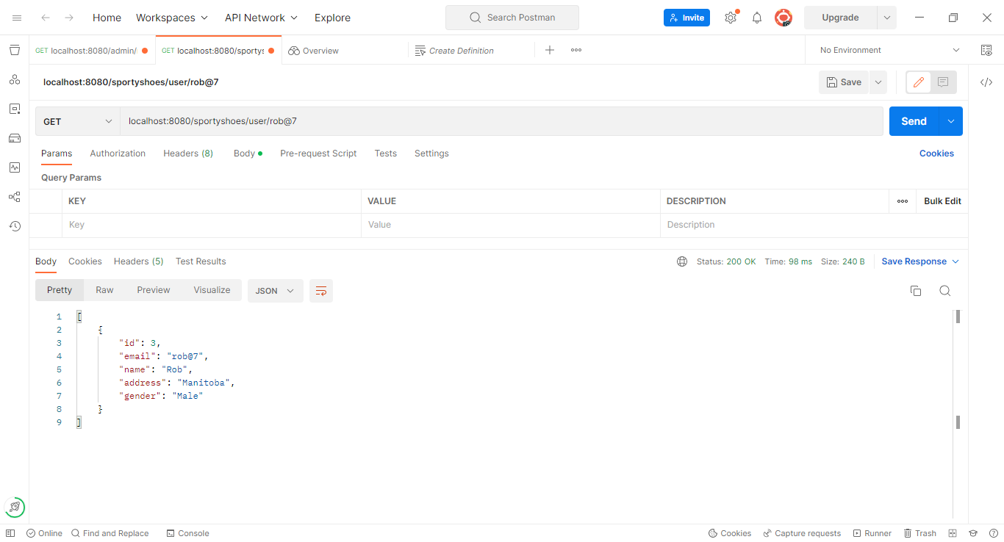

**Purchase Reports Filtered By Date And Category :**

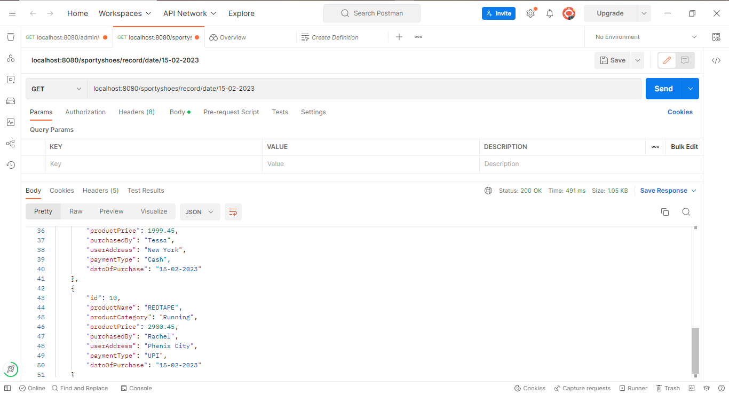

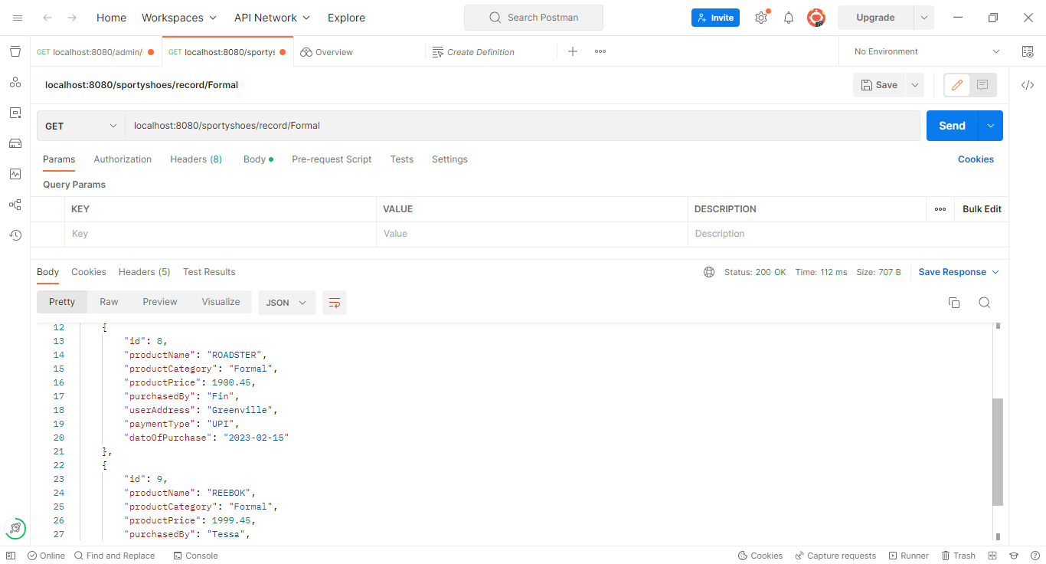

**The Admin can update password if he/she wants :**

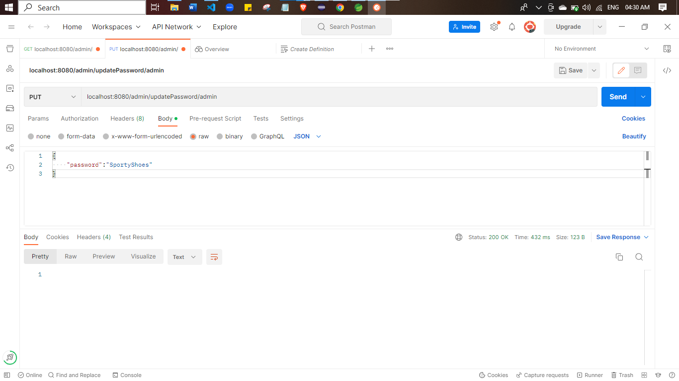

The goal of the company is to deliver a high-end quality product as early as possible. So, In this Project you can perform

* Admin login
* View Products
* View Users
* View Reports
* Add Product
* Update Product
* Delete Product
* Add user
* Update User
* Delete User
* Add Report
* Update Repost
* Delete report
* View Report by Date
* View Report by Category
* View User by Email &
* The Admin can update password if he/she wants

**FINAL SETTING :** Upload files to GitHub Repository

* Open your command prompt and navigate to the folder where you have created your files.
* cd <folder path>
* Initialize repository using the following command:
* git init
* Add all the files to your git repository using the following command:
* git add .
* Commit the changes using the following command:
* git commit . -m <commit message>
* Push the files to the folder you initially created using the following command:
* git push -u origin master

**Unique Selling Points:**

1. This application is use to store & manage the Company products, users & Purchase Record
2. This application will keep on running until user close the program.
3. It allows the admin to add, update , delete, for the products, Users & Purchase Record.
4. It allows the admin to Update Password, Search Reports by date and Category & Search user by email.

**Conclusion:**

Further enhancements to the application can be made which may include

Admin should able to add many data’s in the DB

To create Many methods using Native Query

To deliver better Front-end.

THANK YOU